The Ant and the Grasshopper
The Pilot School
Mr Mansouri Khaled
Student’s name:…………………………………………………………
English Exam - May 2019

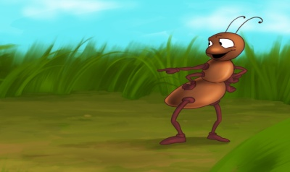
An ant lives next to a Grasshopper. The ant says, “I like to go to school and work.” Every day, the ant gets up at 7:00. She goes to school. She reads and writes. After school, she works and works but the grasshopper doesn’t like to work.
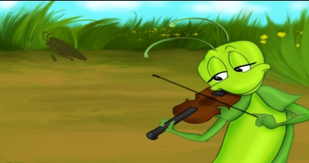
One day, the grasshopper gets up at 10:00. He says, “I like to hop and sing every day.” He wears his clothes and eats breakfast. After breakfast, he hops, sings and watches T.V. At 12:00, he goes back to sleep.
Today it’s cold. It’s winter. The grasshopper hasn’t got any food, so he goes to the ant’s home. He says: “can I eat some of your food.” The ant says:”I work every day but you hop, sing and play.”
The Grasshopper says, “After lunch, I can work.” The Ant gives him some food. After lunch, the grasshopper hops, sings and works!
- Reading Comprehension (6 marks)
- Read and answer the questions: (1 mark)
- What does the Ant do every day?
……………………………………………………………………………………………
- When does the Grasshopper sleep?
…………………………………………………………………………………………….
- Correct the sentences: (1 mark)
- Grasshopper watches T.V in the afternoon.
……………………………………………………………………………………………
- Ant works before school.
…………………………………………………………………………………………….

- Identify true (T) or false (F) sentences: (1 mark)

- The ant hates going to school and work.

- The grasshopper wakes up late.

- Read and match: (2 marks)
A | B | C
- Ant gets up  - Grasshopper gets up  - Ant likes  - Grasshopper likes | - Working and studying  - Early  - Late  - Hopping and singing | A+……  B+……  C+……  D+……

- Complete the sentence from the text: (1 mark)
The grasshopper wears ……………………………… and has …………………………….….
- Language (8 marks)
- Circle the correct alternative: (2 marks)
I’m Sandy. I’m (from-on-at) Boston. I (speak-speaks-speek) English and Italian. I’ve got a (new-old-hot) computer and I write all my letters on it but I don’t like (play-playing-plays) basketball. My favourite pet is the cat.
- Fill in the blanks with words from the box. There is an extra word) (2 marks)
Bedrooms / house / wearing / garden / combing / he / his / has got / brushing

Mr. Arnold…………………. a very large ………………………. There’s a big living-room, a dining-room, three ………………………….. and two bathrooms. There’s a modern kitchen. There’s also a garage and a nice ……………………. . Mr. Arnold is in the bathroom. ….…..is …………………………his teeth. His daughter, Julia, is ………………….her clothes. His son, Peter, is in his bedroom. He’s …………………..his hair.
- Write the opposite of the underlined words: (1 mark)
- Mary has got a old #.........................pet. It’s a big cat. She’s very sad #........................ because she doesn’t like #...............................animals. Today, she gets up late #.......................... to play with her pet.
- Match sentence parts to get correct sentences: (3 marks)
A | B | C
- There’s an eraser  - Today, it’s sunny  - Jane is playing  - There are twelve desks  - She is wearing an  - My little sister is | - The guitar.  - Coloring a picture.  - Old dress.  - In the classroom.  - And the sky is blue.  - In my pencil case. | 1+………  2+………  3+………  4+………  5+………  6+………

- Writing (6 marks)
- Reorder the sentences : (2 marks)
(…..) At 10 o’clock, I play in the playground.
(…..) At twelve o’clock, I go back home.
(…..) Every day, I study Arabic from eight to ten o’clock.
(…..) From ten o’clock to midday, I study Maths and Arabic.
- Write a postcard: (4 marks)
New York
April 6th 2019
Dear Aly,
This is the main Park in New York. It’s a big and nice city with many cinemas and supermarkets.
My house is next to the big park.
Write about Tunisia?
Please write soon.
Love
Smith
Tunisia
May 6th 2019

Dear Smith,
……………………………………………………………………………………………………………………………………………………………………………………………………………………………………………………………………………………………………………………………………………………………………………………………………………………………………………………………………………………………………………………………………………………………………………………………………………………………………………………………………………………………………………………………………………………………………………………………………………………………………………………………………………………

Content adequacy | Grammar accuracy | Capitalization and spelling

GOOD LUCK

